**Advance Excel Assignment 3**

1. How and when to use the AutoSum Command in excel?

Solution: We can use the AutoSum Command to SUM or Add column value which are numeric.

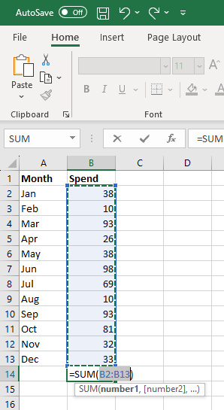

1. What is the shortcut key to perform AutoSum?

Solution: The shortcut key is (Alt + =) sign.

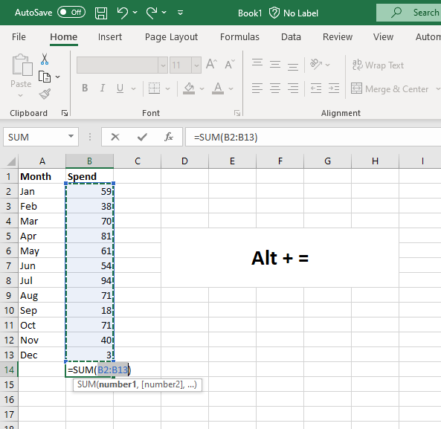

1. How do you get rid of Formula that omits adjacent cells?

Solution: There are four methods to get rid of Formula that omits adjacent cells.

i) Change formulas to include adjacent cells.

ii) Remove unused values.

iii) Ignore error to remove green triangle.

iv) Permanently remove green triangle for this error.

1. How do you select non-adjacent cells in Excel 2016?

Solution:

1. Click on the first cell that you want to be selected. This will now become the active cell.
2. Hold the Control key on your keyboard.
3. Left-click on the mouse and drag to make the selection.
4. Leave the mouse click. At this point, you would have a selection. Continue to hold the Control key.
5. Place the cursor on the second cell/range that you want to select.
6. Left-click on the mouse and drag to make the selection.
7. Leave the mouse click. This would select two non-contiguous range of cells.
8. Release the Control key.
9. What happens if you choose a column, hold down the Alt key and press the letters

Ocw in quick succession?

Solution:

In excel if you select a column and press ocw in quick succession the excel will ask you to increase the column width size which you can enter the value and increase the size as per you preference.

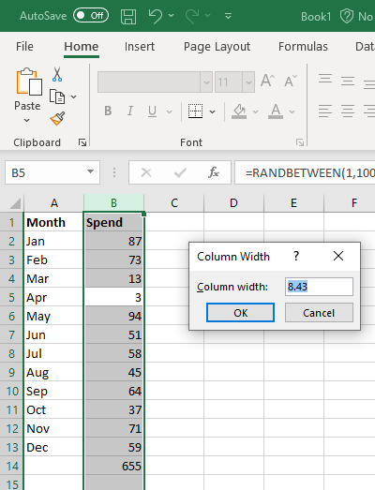

1. If you right-click on a row reference number and click on Insert, where will the row be added?

Solution:

The row will be added on the top if we right-click on a row reference number.

